Web Development Lesson Plan

|  |  |  |
| --- | --- | --- |
| Session: 1-2 weeks after open observation so it is not too fresh | Topic: Targeted observation | Day: 4 |

|  |
| --- |
| Lesson Objective:  This exercise will:   * Instruct students how to setup their own coding environment.   The purpose of this lesson is also that   * Students can identify tools that will aid them in web development. |
| Materials Needed:   * Internet access * Web browser * Computer (Windows, Mac, Linux) |
| Agenda:   1. What is a coding environment? (5 minutes) 2. Visual Studio Code (10 minutes) 3. Visual Studio Code download (5 minutes) 4. Visual Studio Code setup (10 minutes) |
| Procedure:  Student can do this fully independently by reading the instructions, or someone can read the instructions to make sure the task is understood before doing the activity. The reflection part can be done with guided instructions, or in pairs with other students if available to compare notes. |
| Assessment/Check for learning:   * Students can identify concrete things that they missed in their observation (note that this is not a bad thing, the purpose of this lesson is to realize that intentionally looking for information comes with the ‘penalty’ of reduced attention to other things. |

What if:

* Student has already shown proficiency in that skill?
  + Pick a movie or episode in which a lot of things are happening, so that there are more things for the student to keep track of.
* Student is having a hard day and needs special accommodations?
  + Pick a movie or episode in which only a few things are happening, so that there are less things for the student to keep track of.
  + Instead of writing, the student can also take spoken notes with an audio recorder. This will be a bit trickier in the second part but audio in the movie can be supported with subtitles.

NOTES:

* Duration is approximately 50 minutes; can be adjusted by shortening the duration of the film clip. Less than 10 minutes is not recommended unless really necessary.

**Instructions**

**What is a coding environment? (5 minutes)**

Step 1:

A coding environment is a collection of tools that aid in writing code. These tools are computer programs that you install on your machine. Some of these tools are code editors and system terminals. Most code editors come packed with all the tools you need to write code. Coding environments are often referred to as IDE’s (Integrated Development Environment).

Step 2:

Watch the following video to learn about IDE’s:

[What is an IDE?](https://www.youtube.com/watch?v=vUn5akOlFXQ)

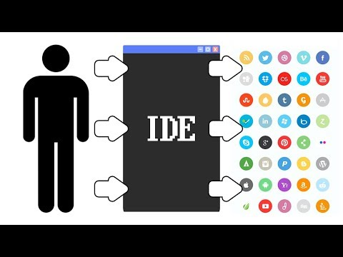

**Visual Studio Code (10 minutes)**

Step 1:

For this course we will be using Visual Studio Code, an IDE that supports many languages and is equipped with useful tools. Visual Studio Code makes it easy to manage your code and offers features to automate repetitive tasks. It essentially makes you write code much faster than using a regular text editor. Visual Studio Code also offers a free app store that allows you to install plugins and even color themes to make your environment just the way you like.

Step 2:

Read the following article to learn why Visual Studio Code is the right IDE for this course and for future projects:

<https://code.visualstudio.com/docs/editor/whyvscode>

**Visual Studio Code download (5 minutes)**

Step 1:

Visit the following link and click download:

<https://code.visualstudio.com/>

**Visual Studio Code setup (10 minutes)**

Step 1:

Watch the following video to setup your Visual Studio Code. Since we are using Python as our main programming language, make sure to install the Python plugin from the extension marketplace.

[Getting started with Visual Studio Code](https://www.youtube.com/watch?v=S320N3sxinE)

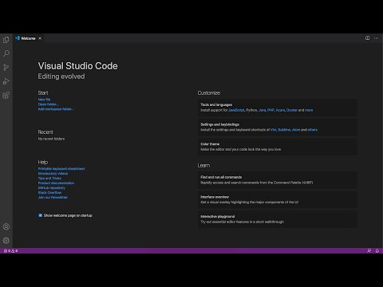

In the next lesson you will learn about basic linux commands and file structures.